**Quarterly Report – Public Page**

**Date of Report:** *8th Quarterly Report, September 27, 2024*

**Contract Number:** *693JK32210001POTA*

**Prepared for:** *Government Agency: DOT and Co-funders*

**Project Title:** *Developing Corrosion Control Monitoring Technology for Hazardous Liquid Breakout Tanks*

**Prepared by:** *Pipeline Research Council International, Inc.*

**Contact Information:**  *Janie Norton,* [*jnorton@prci.org*](mailto:jnorton@prci.org) *703-205-1600 ext: 105*

**For quarterly period ending:** *September 30, 2024*

**1: Items Completed During this Quarterly Period:**

|  |  |  |  |  |  |
| --- | --- | --- | --- | --- | --- |
| ***Item***  ***#*** | ***Task***  ***#*** | ***Activity/Deliverable*** | ***Title*** | ***Federal Cost*** | ***Cost Share*** |
| 19 | 5 | Quarterly Project Management & Status Update Reporting | Submit 7th quarterly report | $0 | $0 |
|  |  |  |  |  |  |

**2: Items Not Completed During this Quarterly Period:**

|  |  |  |  |  |  |
| --- | --- | --- | --- | --- | --- |
| ***Item***  ***#*** | ***Task***  ***#*** | ***Activity/Deliverable*** | ***Title*** | ***Federal Cost*** | ***Cost Share*** |
|  |  | None |  |  |  |

**3: Project Financial Tracking During this Quarterly Period:**

Note that this chart reflects Federal share only.

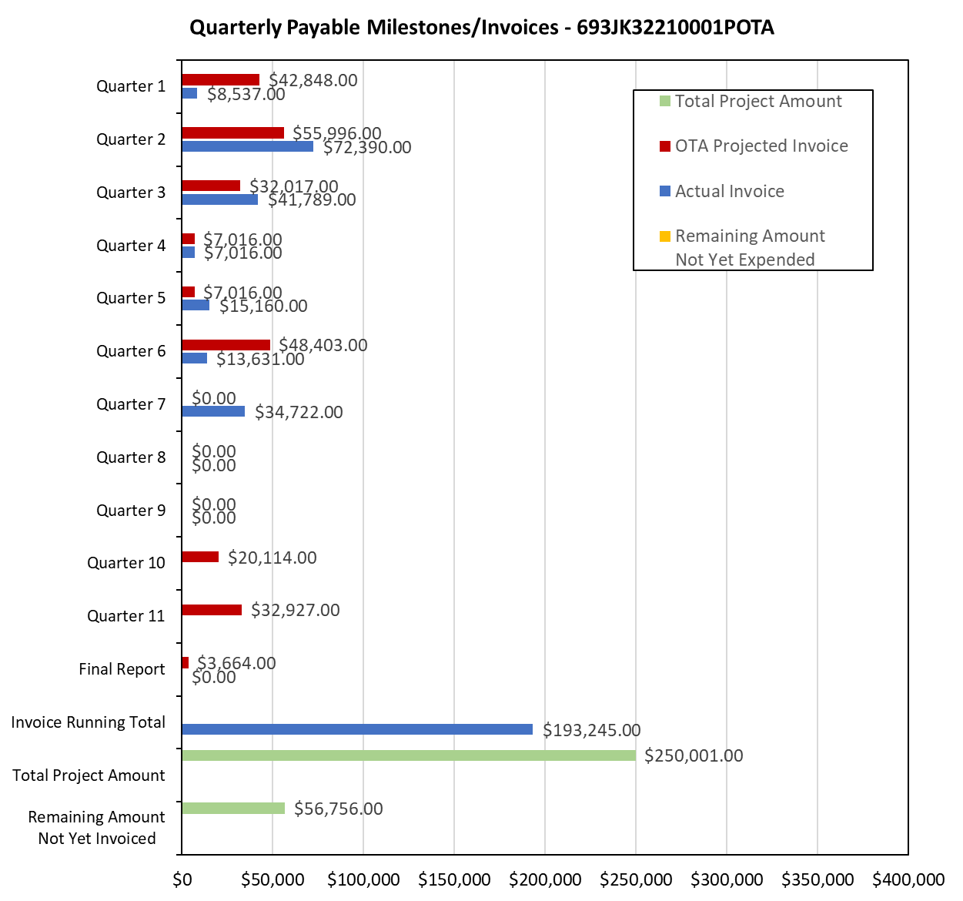

**4: Project Technical Status:**

**Item 19, Task 5 - Quarterly Project Management & Status Update Reporting.** Submit 8th quarterly report: The 8th quarter project meeting was held on September 4, 2024. This item has been completed. This item links to items 10 and 12 in Attachment 1 Team Project Activities. This item also links to item 10 in Attachment 2 Project Deliverables.

**5: Project Schedule:**

The project is behind schedule, and a 9-month no-cost extension request was submitted and approved.  The project is on-track as per the revised deliverable schedule.